TRAVEL AGENCY OFFERING PACKAGES AT REASONABLE PRICES

PROJECT REPORT

Submitted By

GROUP NO.22-A
PROJECT GROUP NO. 3

HARMANPREET SINGH. 2310991923
HARSEHEJPREET KAUR. 2310991924
HARSHIT GUPTA. 2310991927

in partial fulfilment for the award of the degree

of

BACHELOR OF ENGINEERING

in

COMPUTER SCIENCE & ENGINEERING


CHITKARA UNIVERSITY

CHANDIGARH-PATIALA NATIONAL HIGHWAY
RAJPURA (PATIALA) PUNJAB-140401 (INDIA)

Abstract

The purpose of Travel Website is to automate the existing manual system by the help of computerised equipment and full fledged computer software, fulfilling their requirements, so that their valuable data/information can be stored for a longer period with easy accessing and manipulation of the same. The required software and hardware are easily available and easy to work with.Travel Website, as described above can lead to error free, secure, reliable and fast management systems. It can assist the user to concentrate on their other activities rather than concentrating on the record keeping. Thus it will help organisations in better utilisation of resources. The organisation can maintain computerised records without redundant entries. That means that one need not be distracted by information that is not relevant, while being able to reach the information.Every organisation, whether big or small has challenges to overcome and manages the information of Tour, Travel, Hotel, Customer,Facility. Every Travel Website has different Travel needs, therefore we design exclusive employee management systems that are adapted to your managerial requirements.This is designed to assist in strategic planning and will help you ensure that your organisation is equipped with the right level of information and details for your future goals. Also, for those busy executives who are always on the go, our systems come with remote access features, which will allow you to manage your workforce anytime, at all times. These systems will ultimately allow you to better manage resources.

Content Of Report

Sr No. | Topics
1 | Introduction  - Figure 1.1 Adventure is Worthwhile
2 | Problem Statement
3 | Key Features
4 | Highlights Of Our Webpage
5 | Result  - Figure 5.1 Packages  - Figure 5.2 Services
6 | Conclusion
7 | References

1. Introduction

The purpose of this project is to design and develop a responsive website for a tour and travel agency.The website aims to provide users with information about various and reasonable travel packages, destinations and booking options.Our website is designed to be your virtual gateway to a world of adventure, relaxation, and cultural exploration.We believe that travel is not just about reaching a destination; it's about the stories you collect along the way. With a commitment to excellence and a passion for exploration, we've curated a collection of extraordinary destinations and immersive experiences just for you.This software is supported to eliminate and in some cases reduce the hardships faced by this existing system. Moreover this system is designed for the particular need of the company to carry out operations in a smooth and effective manner.We are dedicated in creating exceptional travel experiences for our clients.

Travel Website, as described above can lead to error free, secure, reliable and fast management system.It can assist the user to concentrate on their other activities rather to concentrate on record keeping.

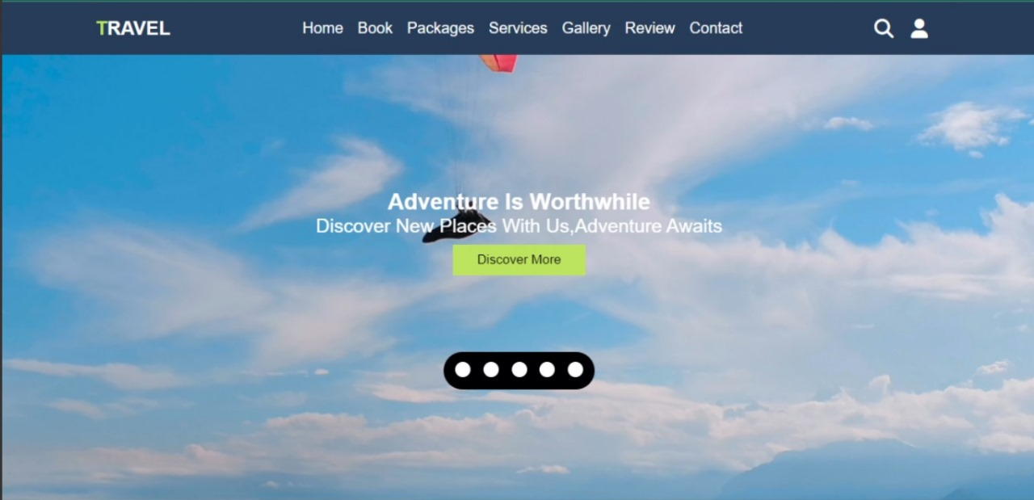
Fig 1.1 Adventure is worthwhile

2. Problem Statement
Travel Agency aims to improve customer satisfaction and increase bookings by enhancing its online booking platform. The current system faces issues with slow response times, limited user interactivity, and outdated design, leading to decreased user engagement and conversion rates. Essential information, such as travel packages, destination details, and pricing, is not presented clearly and concisely.The lack of visible trust indicators and customer reviews contributes to a hesitancy among potential customers. The goal is to develop a more user-friendly, intuitive, and efficient online platform to provide customers with a seamless booking experience. This problem statement outlines the current challenges faced by the travel agency and identifies the objectives and aims at the development of a new and improved website that focuses on user experience, security, and modern features is essential to overcoming these issues and ensuring the success of the travel agency's online presence.

NO HTTP SECURITY (Hypertext transfer protocol) secure, when you type your domain name into Google Chrome, it will display a gray background — or even worse, a red background with a “not secure” warning. Malicious software is used to infect websites, gather data and in some cases even hijack computer resources. Site security with HTTPS is most important.

SITE IS NOT INDEXED CORRECTLY If you see a message that your site is not indexed, it may be because it is indexed under a different domain. For example, if you receive a message that (http://example.com) is not indexed, make sure that you've also added (http://www.example.com) to your account (or vice versa), and check the data for that site.

3. Key Features

3.1 Discover Unique Destinations:
Embark on a virtual tour of the world's most captivating destinations. From the sun-kissed beaches of tropical paradises to the rich history of ancient cities, our curated selection promises something for every kind of traveller.

3.2 Tailored Tour Packages:
Our meticulously crafted tour packages cater to diverse interests and preferences. Whether you're an adventure seeker, a cultural explorer, or someone in search of relaxation, our packages are designed to turn your travel dreams into reality.

3.3 Effortless Booking:
Planning your dream getaway has never been easier. Our user-friendly website ensures a seamless booking experience, allowing you to customise your journey with just a few clicks. Our dedicated customer support team is always ready to assist you.

3.4 Our Mission:
Our mission is to inspire and enable individuals to explore the world, fostering a deeper understanding of diverse cultures and creating connections that transcend borders. We strive to be the preferred choice for travellers seeking seamless and enriching journeys.

3.5 Destination Expertise:

With a team of passionate travel experts, we provide in-depth knowledge and insights into a wide array of destinations. From hidden gems to iconic landmarks, we guide you to the heart of each location, ensuring an authentic and immersive experience.

4. Highlights Of Our Webpage

4.1 Accessibility Features:
The webpage is easily accessible to the users with disabilities by incorporating semantic HTML, providing alternative text for images and adhering to web accessibility standards.
4.2 Search Functionality:
The webpage includes a search bar to help users quickly find specific information as well they can plan their amazing tours hassle free.Navigation bar provides links to different sections of the website for easy navigation.
4.3 Interactive Elements:
Incorporates interactive elements, such as buttons, hover effects, or animations, to enhance user engagement.The cohesive colour scheme that aligns with the brand identity and creates a visually pleasing experience.Consistent and well-chosen fonts contribute to readability and overall design aesthetics.
4.4 Content Sections:

Organised sections that present information in a structured manner. These may include text, images, videos, or other multimedia elements. Website includes user-friendly forms for various purposes, such as contact forms, registration forms, or search forms.A good web page provides a user-friendly experience, effectively communicates information, and aligns with the overall goals of the website.

4.5 High-Quality Imagery and Multimedia:

There is effective use of multimedia elements, such as interactive content to engage users. The relevant images are added to the webpage that enhance the overall visual appeal.

5. Result

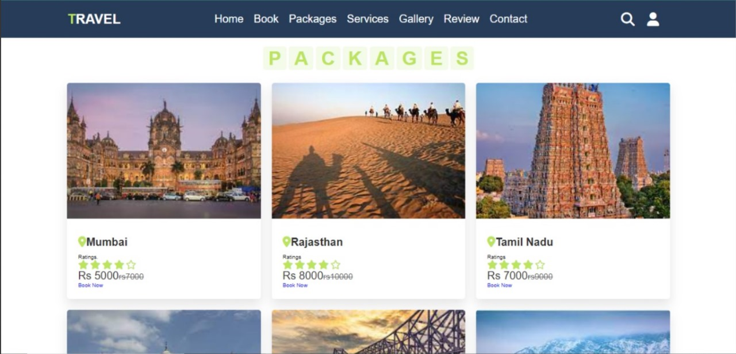 Fig 5.1 Packages

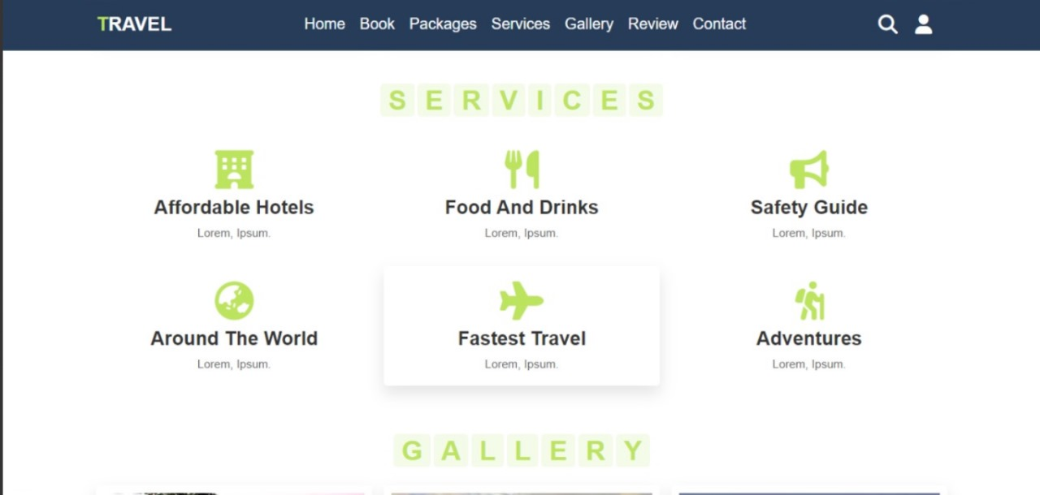 Fig 5.2 Services

6. Conclusion
As you have navigated through our pages, we hope you have discovered the world of possibilities that travel brings. Our Travel website is your gateway to extraordinary travel adventures. Our commitment to providing seamless and unforgettable experiences is reflected in every aspect of this site, from the user-friendly design to the diverse range of curated tour packages.HTML (HyperText Markup Language) and CSS (Cascading Style Sheets) play crucial roles in creating and designing web pages. Each language serves a distinct purpose in the structure and presentation of a webpage.The html provided a means to create structured documents by denoting structural semantics for text such as headings, paragraphs, lists, links, quotes and other items.CSS has played an important role in creating the visual styling.It has enabled us to maintain a consistent look.It supports the animations and transitions along with accessibility.

- References
We take references from the following websites:
1) https://www.w3schools.com/html/default.asp
2) https://www.w3schools.com/css/default.asp
3) https://www.w3schools.com/js/default.asp

